**DAILY ONLINE ACTIVITIES SUMMARY**

|  |  |  |  |  |  |  |  |  |
| --- | --- | --- | --- | --- | --- | --- | --- | --- |
| **Date:** | **11-6-2020** | | | | | **Name:** | **Prajna** | |
| **Sem & Sec** | **8th sem ‘B’** | | | | | **USN:** | **4AL16CS067** | |
| **Online Test Summary** | | | | | | | | |
| **Subject** | | **SMS** | | | | | | |
| **Max. Marks** | | **60** | | **Score** | | | **60** | |
| **Certification Course Summary** | | | | | | | | |
| **Course** | **Introduction to python programming** | | | | | | | |
| **Certificate Provider** | | | **Great Learning** | | **Duration** | | | **4hrs** |
| **Coding Challenges** | | | | | | | | |
| **Problem Statement:**1**.** Write a java program to print the count of alphabets constants and numbers. | | | | | | | | |
| **Status: Completed** | | | | | | | | |
| **Uploaded the report in GitHub**  **GitHub link:** | | | | | **Yes**  **https://github.com/alvas-education-foundation/prajna_k** | | | |
| **If yes Repository name** | | | | | **prajna_k** | | | |
| **Uploaded the report in slack** | | | | | **yes** | | | |

Online Test Details: (Attach the snapshot and briefly write the report for the same)

Certification Course Details: (Attach the snapshot and briefly write the report for the same)

Coding Challenges Details: (Attach the snapshot and briefly write the report for the same)

1)online test

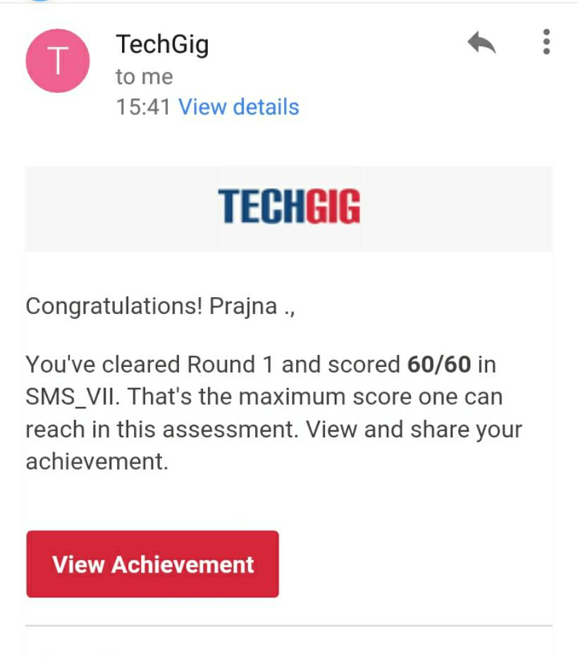

2) certification course

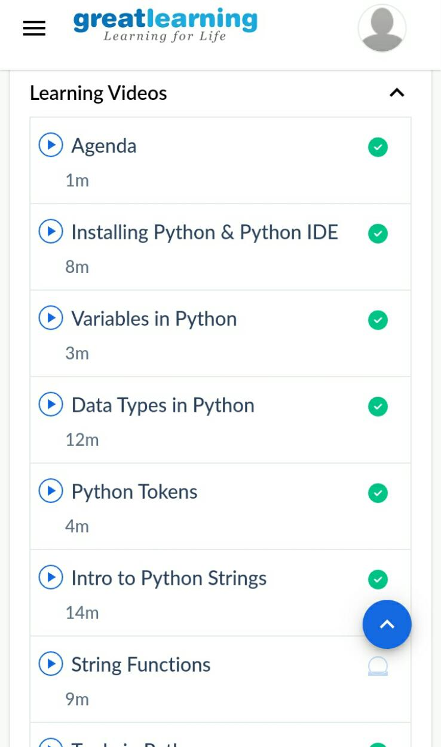

3) coding challenges

Program 1

#include <stdio.h>

#include <string.h>

#include <stdlib.h>

#define str_size 100

void main()

{

char str[str_size];

int alp, digit, splch, i;

alp = digit = splch = i = 0;

printf("\n\nCount total number of alphabets, digits and special characters :\n");

printf("--------------------------------------------------------------------\n");

printf("Input the string : ");

fgets(str, sizeof str, stdin);

while(str[i]!='\0')

{

if((str[i]>='a' && str[i]<='z') || (str[i]>='A' && str[i]<='Z'))

{

alp++;

}

else if(str[i]>='0' && str[i]<='9')

{

digit++;

}

else

{

splch++;

}

i++;

}

printf("Number of Alphabets in the string is : %d\n", alp);

printf("Number of Digits in the string is : %d\n", digit);

printf("Number of Special characters in the string is : %d\n\n", splch);

}

|  |
| --- |
|  |
|  |  |
|  |  |
|  |  |
|  |  |
|  |  |